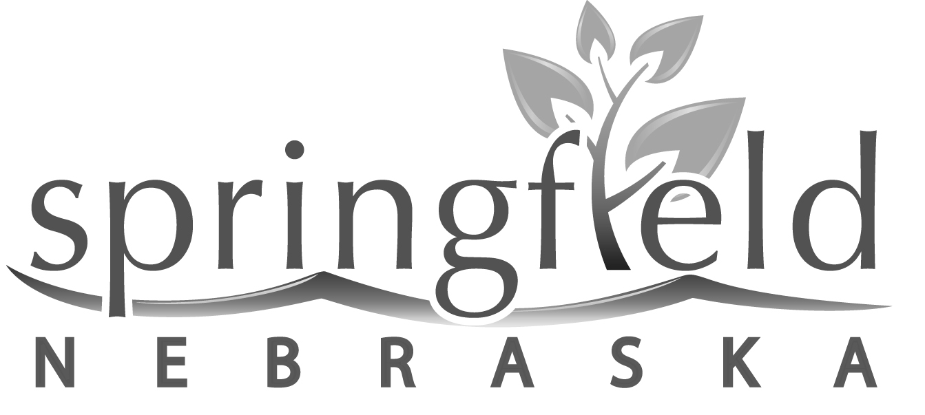

CITY COUNCIL AGENDA
Tuesday, September 20, 2022
Springfield City Hall
170 North 3rd Street

CALL TO ORDER

- Public announcement that a copy of the Nebraska Open Meetings Law is posted in the entry to the meeting room

- Roll call

- Pledge of Allegiance

BUDGET HEARING & BUDGET SUMMARY
Tuesday, September 20, 2022
7:00 p.m.

- Budget Discussion, in compliance with the provisions of Nebraska State Statute Sections 13-501 to 13-513, that the Governing Body will meet for the purpose of hearing support, opposition, criticism, suggestions or observations of taxpayers relating to the FY22-23 proposed budget.

SPECIAL HEARING TO SET FINAL TAX REQUEST
Tuesday, September 20, 2022
This hearing will immediately follow the Budget Hearing & Budget Summary Hearing.

1. Public Hearing, in compliance with the provisions of Nebraska State Statute Section 77-1601.02, that the Governing Body will meet for the purpose of hearing support, opposition, criticism, suggestions or observations of taxpayers relating to setting the final tax request at a different amount than the prior year tax request.

CONSENT AGENDA
The regular Council meeting will immediately follow the Special Hearing to Set Final Tax Request. All consent agenda items are approved in one motion unless removed by a Council Member. Removed items will be placed under the Regular Agenda for consideration and action by the Council.

- Approve Minutes of the September 6, 2022 Council Meeting
2. Approve Treasurer’s Report

3. Approve Claims

4. Close Main Street from South 9th Street to Railroad Street and Railroad Street from Main Street to Spruce Street for the Springfield Platteview High School Homecoming Parade scheduled for Wednesday, September 28 at 7:00 p.m.; and close North 2nd Street from Main Street to the alley for food truck vendors from 5:30 p.m. to 8:00 p.m.

5. Kelli Haynes, Nurse for Springfield Platteview Community Schools – Request to waive the Community Building rental fee for a community flu shot clinic on Sunday, October 16 from 12:00 p.m. to 4:00 p.m.

6. Consider approval of Resolution 2022-34 entering into a Master Agreement Work Order with Olsson for General Engineering Consulting Services

7. Consider approval of Resolution 2022-35 entering into a Master Agreement Work Order with Olsson for Street Superintendent Services

8. Consider approval of Resolution 2022-36 entering into a Master Agreement Work Order with Olsson for Bridge Inspection Services

9. Consider approval of Resolution 2022-37 directing the sale of city property (miscellaneous library items) in “as is” condition, to the highest bidder, which bids will be opened on Monday, October 3, 2022, beginning at 10:00 a.m. at Springfield Memorial Library, 665 Main Street, Springfield, NE 68059

REGULAR AGENDA

- Consider approval of the City Lottery Sales Outlet Location Application for new owners of The Blind Pig, LLC, 167-169 Main Street, Springfield

- Exceed the budget lid limit by an additional 1% for the fiscal year 2022-2023

- Consider adopting Resolution 2022-38 to request the new property tax rate be changed from the levy rate of the prior year to the levy rate for the General Fund of 0.50 and the Bond Fund of 0.132115 for a total levy rate of 0.632115 for FY2022-2023 and to request the FY2022-2023 property tax request be set at $831,572.65 for the General Fund and $219,726.25 for the Bond Fund, for a total of $1,051,298.90

- Consider approval of Ordinance No. 1106 to adopt the budget statement to be termed the annual appropriation bill; to appropriate sums for necessary expenses and liabilities

- Consider approval of Ordinance No. 1107 designating Horizon Bank of Springfield, Nebraska and Pinnacle Bank of Springfield, Nebraska as city depositories for the City of Springfield, Nebraska for the fiscal year October 1, 2022, to September 30, 2023

- Consider approval of Ordinance No. 1108 establishing the amount of certain fees and taxes charged by the City of Springfield for various services; including changes to water and sewer rates; repealing ordinances in conflict; and providing for an effective date

- Consider approval of the following Ordinance Nos. 1109 thru 1120 as they are part of the 2022 legislative update:

  - Ordinance No. 1109 Amend §1-203 Appointed Officials; City Clerk
  - Ordinance No. 1110 Amend §1-509 Meetings; Public Participation
  - Ordinance No. 1111 Amend §1-606 Ordinances; Reading and Passage of Ordinances, Resolutions, Orders, Bylaws
  - Ordinance No. 1112 Amend §1-607 Ordinances; Publication or Posting
  - Ordinance No. 1113 Amend §1-722 Elections; Candidate Filing Forms; Deadlines; Filing Officer
  - Ordinance No. 1114 Amend §1-804 Fiscal Management; Adopted Budget Statement; Filing; Certification of Amount of Tax
  - Ordinance No. 1115 Amend §1-822 Fiscal Management; Property Tax Request; Procedure for Setting
  - Ordinance No. 1116 Amend §4-303 Nuisances; Abatement Procedure
  - Ordinance No. 1117 Adopt §5-215 Restrictions on Direction of Travel
  - Ordinance No. 1118 Amend §6-326 Misdemeanors; Abandoned Automobiles
  - Ordinance No. 1119 Amend §6-339 Misdemeanors; Gambling
  - Ordinance No. 1120 Amend §10-109 Alcoholic Beverages; Licenses; City Powers and Duties

- Tabled September 6, 2022. Consider bids for the purchase of new playground equipment at City Park

- Tabled September 6, 2022. Consider bids for the purchase of new basketball hoops at City Park

- Consider purchase of 2022 GMC 3500 truck in the amount of $44,199 from Copple Chevrolet (includes $3,500 trade-in for the 2004 and 1989 trucks); Consider purchase of a snowplow for the 2022 GMC truck in the amount of $10,566.45 from Ty’s Outdoor Power & Service

- Consider purchase of Bobcat UV34 (gas) Utility Vehicle from Bobcat of Omaha in the amount of $19,839.45; Consider purchase of a snowplow for the Bobcat UTV in the amount of $5,241.44 from Ty’s Outdoor Power & Service

- Consider the purchase or lease of Aquos Board from Eakes Office Solutions for the purchase price of $5,453 or a monthly payment of $102.90 via a 60-month lease

- Consider purchase of Bobcat TL619 Telehandler from Bobcat of Omaha in the amount of $80,373.52

- Consider purchase of NorthStart heavy-duty trailer with 600-gallon water tank from Northern Tool & Equipment in the amount of $5,999.99

- Consider projects for the 2023 One and Six Year Road Plan

- Appoint Kellie Seiber as the new Library Director and consider a wage increase effective October 1, 2022

- Amend wages for Connie Manzer, Assistant Library Director; Jean Latham, Library Aide; and Salley Seiber, Library Aide effective October 1, 2022

- Discuss Elliott Smart’s annual review and consider a proposed merit increase

- Discuss Bryan Cherry 6-month review and consider proposed merit increase

- Discuss Tyler Holdorf’s 6-month review and consider a proposed merit increase

- Consider COLA increase for regular full-time employees (40 hours) and regular part-time employees (30+ hours)

DEPARTMENT REPORTS

- Sewer Department – Mike Neitzel

- Library & Community Building – Michael Herzog

- Water & Parks Department – Kacie Murtha

- Street Department – Dan Craney

5. Mayor’s Report – Bob Roseland

6. City Staff Reports

The Mayor and City Council reserve the right to adjourn into executive session per Section 84-1410 of the Nebraska Revised Statutes.

ADJOURNMENT

